KEY NOTES

-Each committee should find one hour to talk about tabling this week with their committee.

-We will have a post-it note board in front game room to collect opinion on theme idea.

-Budget overall is 25k.

-Each committee will need to come up with their ideas and supply list.

MONTE CARLO BUDGET

35k in total – 10k casino = 25k.

MEETING NOTES

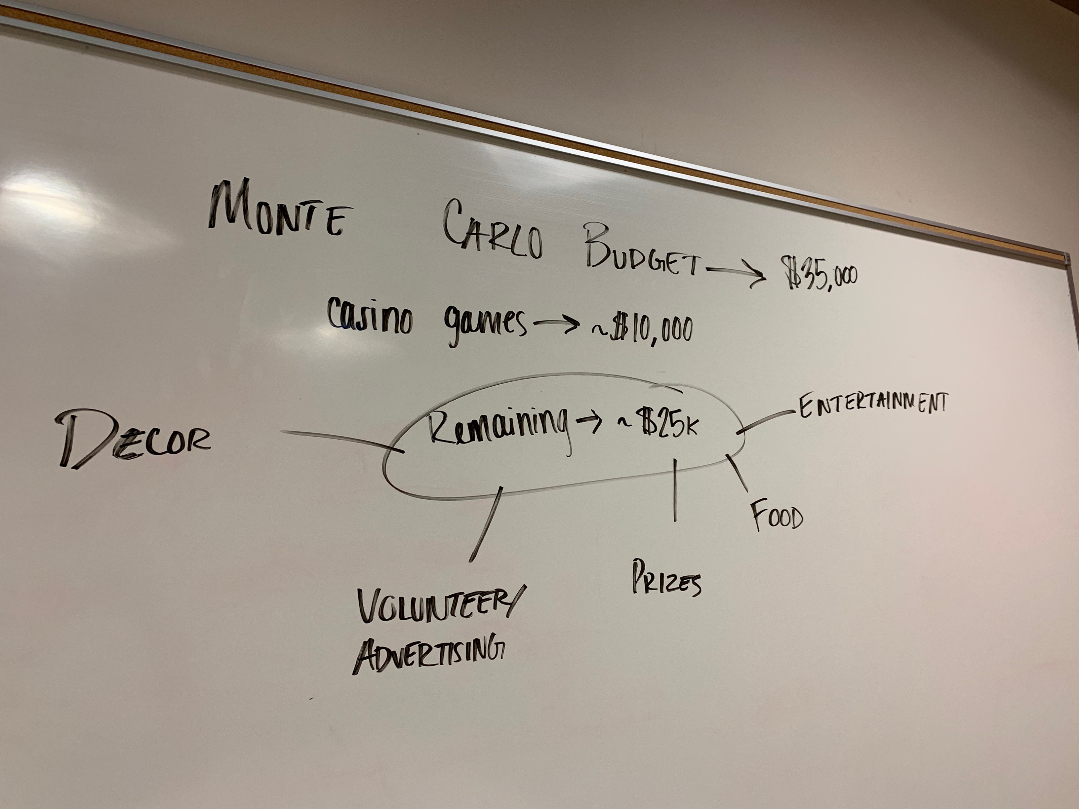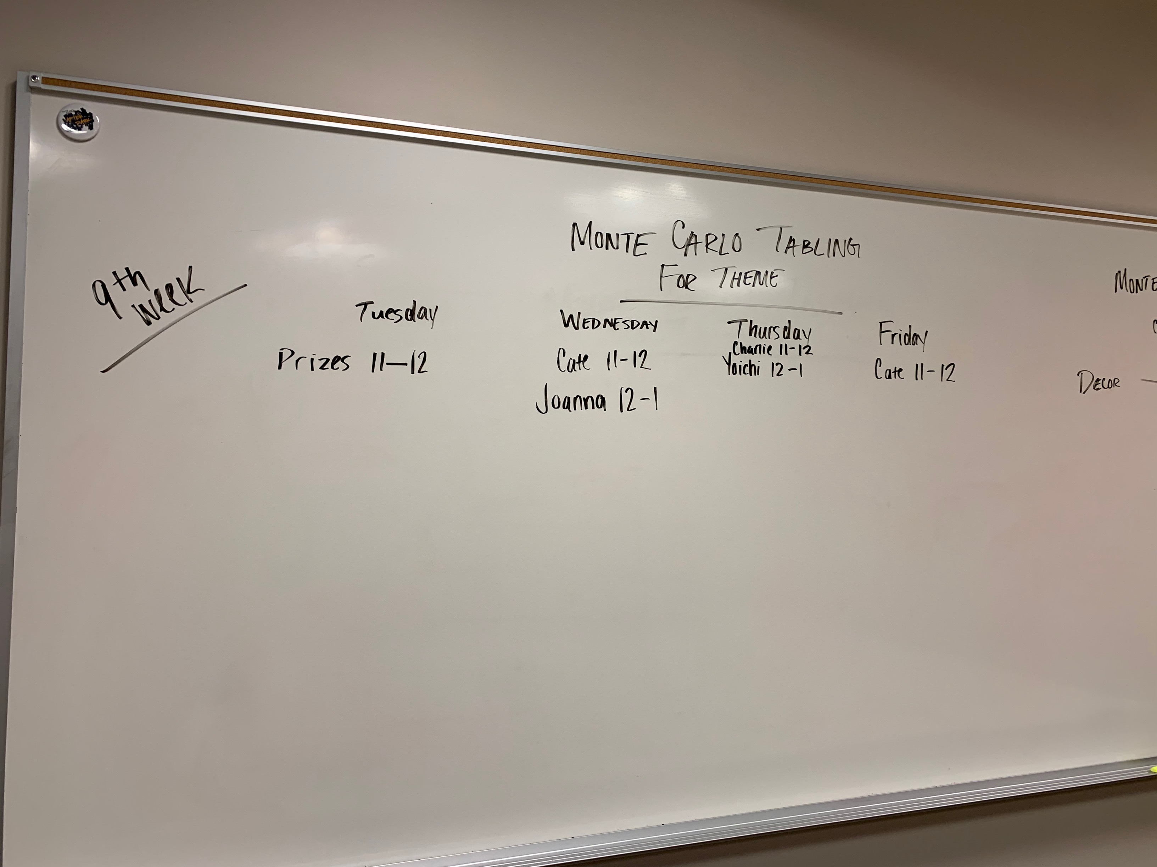

- We will hold a voting opinion booth in front game room. The bulletin board info data will be used to voice what students want the theme may be and/or voice their own theme ideas.

-Bulletin board duty:

|  |  |  |  |  |
| --- | --- | --- | --- | --- |
| Tue | Wed | Thurs | Fri | 9TH Week |
| Prizes 11-12 | Cate 11-12 | Yoichi 12-1 | Cate 11-12 |  |
|  | Joanna 12-1 | Charlie 11-12 |  |  |

FOOD

-Will continue to talk with K Food Catering about food truck options.

PRIZES

-Promo (Tshirts, mugs, etc.) -Must be ordered by the end of March.

-Will talk with volunteer team.

* We had a meeting and discussed a little about what we need to do as a prizes group, was wondering if there was anything from past Monte Carlo’s for a crutch/general outline of prizes, if not then we are capable of figuring it out

- Also briefly discussed how we will be ordering prizes (online, in person, etc, whatever has the best deals for good quality)

* Entertainment, when ready, needs to reach out to us when they know what games they want specific prizes at

- Discuss what kind of prices (low-risk prizes)

- Discuss if they are doing raffles with prizes or not

* Discuss the lunch with Jorge with the volunteer committee (determine which group is going to use that as prizes)
* Also, discuss with the volunteer group what prizes will be involved with giving to volunteers and purchasing the bears together from the bookstore
* When/who should we email about the parking spot prize, k cash prizes, ringing the church bell?

- Who must approve these?

* For the tabling, we plan on getting prize ideas from the student body by having them write ideas on a whiteboard or just letting us know and we record it (know what small prizes, large prizes, and cost-free prizes they would like to do)

- What else should we be asking of them?

* Any chance we can post the meeting minutes on teams after every meeting (from lizzy since she can’t make some of the meetings due to practice)

VOLUNTEERS

-Will reach out to staff and faculty if they are open by 9-10th week.